**CS595 - Assignment 2**

1. (1 point) Execute the following hdfs command and take a screen snapshot of the names of the files or directories that are listed (also indicating which is a file and which a directory):

hadoop fs –ls /

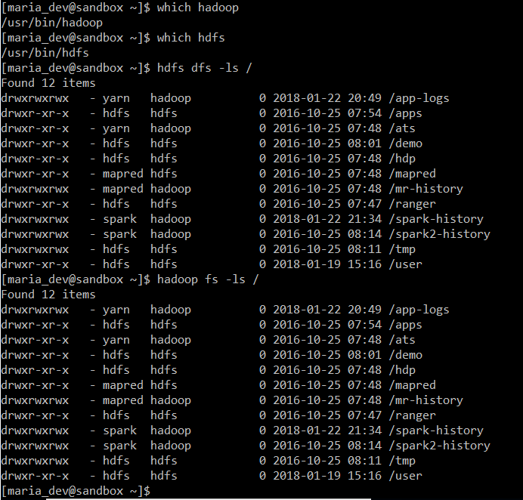

Command Executed:

hdfs dfs -ls /

hadoop fs -ls /

1. (1 point) Execute a command (you needed to figure out which one) to list the files and subdirectories under the hdfs directory listed below:

/user

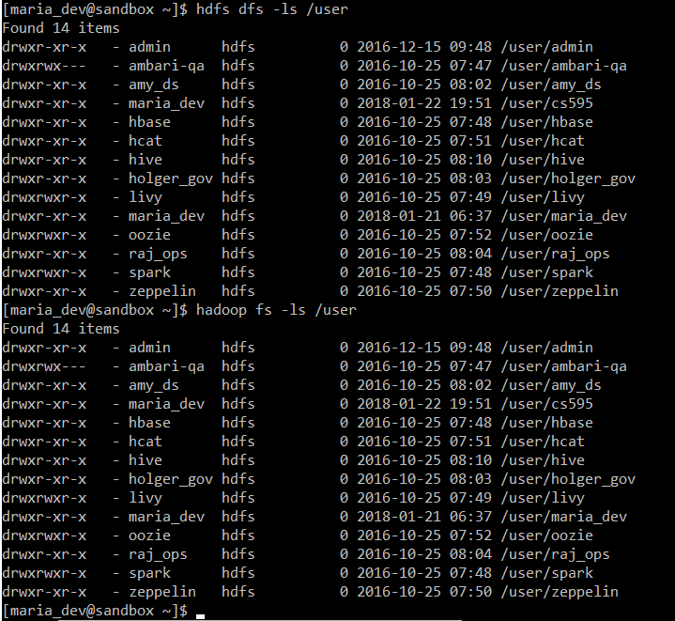

Command Executed:

hdfs dfs -ls /user

hadoop fs -ls /user

1. (2 points) Execute a command to create the following directory:

/user/cs595/<yournamenospaces>

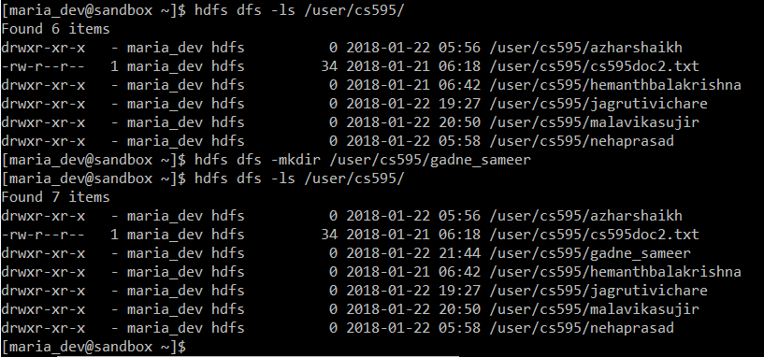

Command Executed:

hdfs dfs -mkdir /user/cs595/gadne_sameer

1. (2 points) Execute a command that copies a given local file (that I already created for you) to the given hdfs directory :

Local file: /home/maria_dev/cs595doc.txt

HDFS directory: /user/cs595/<yournamenospaces>

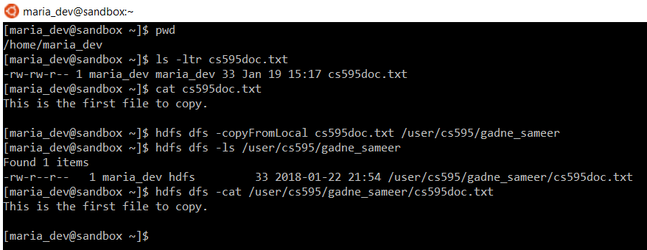

Command Executed:

hdfs dfs -copyFromLocal cs595doc.txt /user/cs595/gadne_sameer

1. (2 points) Copy the given file from one hdfs directory to another hdfs directory and write down the command

Source hdfs file: /user/cs595/cs595doc2.txt

Destination HDFS directory: /user/cs595/<yournamenospaces>

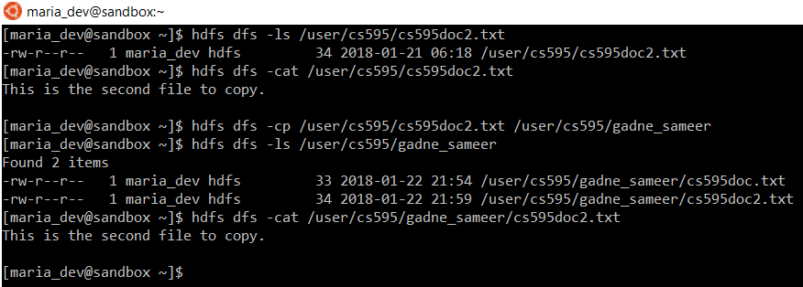

Command Executed:

hdfs dfs -cp /user/cs595/cs595doc2.txt /user/cs595/gadne_sameer

1. (2 points) This is to get you familiar with the approach to copy files from your MAC or PC to a local account on the Linux machine running the Hadoop Sandbox.

* Create a plain text file on your local machine (PC or MAC). Name it firstname_lastname.txt. The file should hold just one line and that line should hold your first and last name.
* Open a new terminal or bash window
* Copy the local file firstname_lastname.txt to the maria_dev account as follows:
  + scp –P 2222 ./firstname_lastname.txt maria_dev@localhost:/home/maria_dev
  + When prompted for a password, enter
    - maria_dev
  + Note that the “ssh” command used a small p (-p) to specify the port, the scp command uses a capital P (-P) to do so.
* Now, from your hadoop maria_dev account, execute a command that copies the firstname_lastname.txt file to the given hdfs directory :

Local file: /home/maria_dev/firstname_lastname.txt

HDFS directory: /user/cs595/<yournamenospaces>

scp the “gadne_sameer.txt” from Windows to Linux server:



Command to copy the “gadne_sameer.txt” file from Hadoop maria_dev account to HDFS directory /user/cs595/gadne_sameer/:

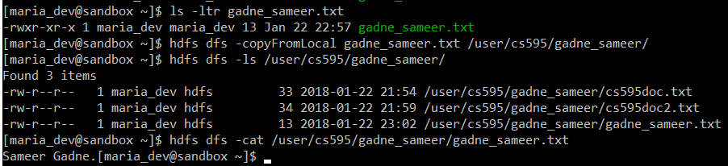

Command Executed:

scp -P 2222 ./gadne_sameer.txt maria_dev@localhost:/home/maria_dev

hdfs dfs -copyFromLocal gadne_sameer.txt /user/cs595/gadne_sameer/

hdfs dfs -ls /user/cs595/gadne_sameer/

hdfs dfs -cat /user/cs595/gadne_sameer/gadne_sameer.txt